**RAZORPAY INTEGRATION**

**Razorpay** is a software used for safe money transactions .

Below are the steps to properly execute the given files in my Github repository.

Recommended Platform -> XAMPP

**Step 1:**

Firstly copy the uploaded files to your ‘htdocs’ folder ,this folder can be found in the location where you installed your XAMPP.

**Screenshot:**

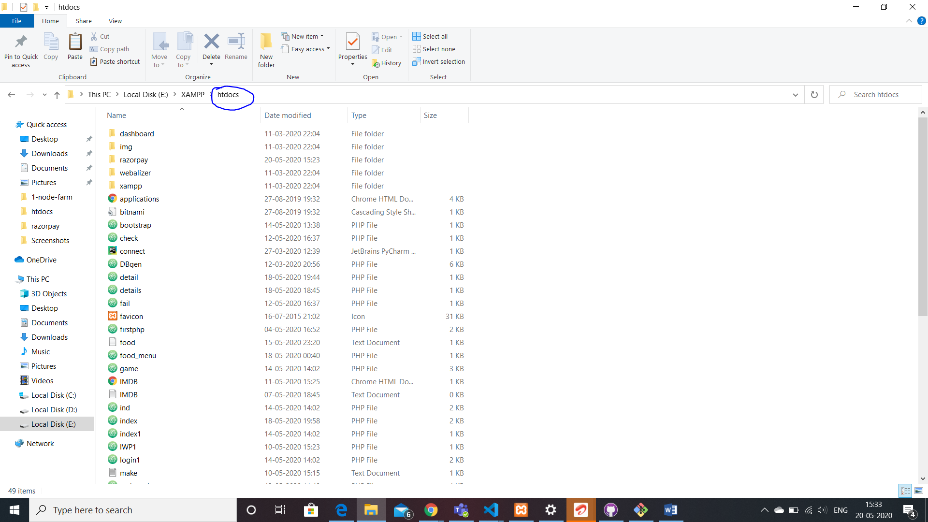

**Step 2:**

Create a database named “**razor_pay**” in your **phpmyadmin .**

After creating the database add a table named “**details**” to this database .

In this details table, add columns : name,email,amount,contacts with their datatypes as varchar(30),varchar(40),int(11),**bigint(20)** respectively.

**Screenshot:**

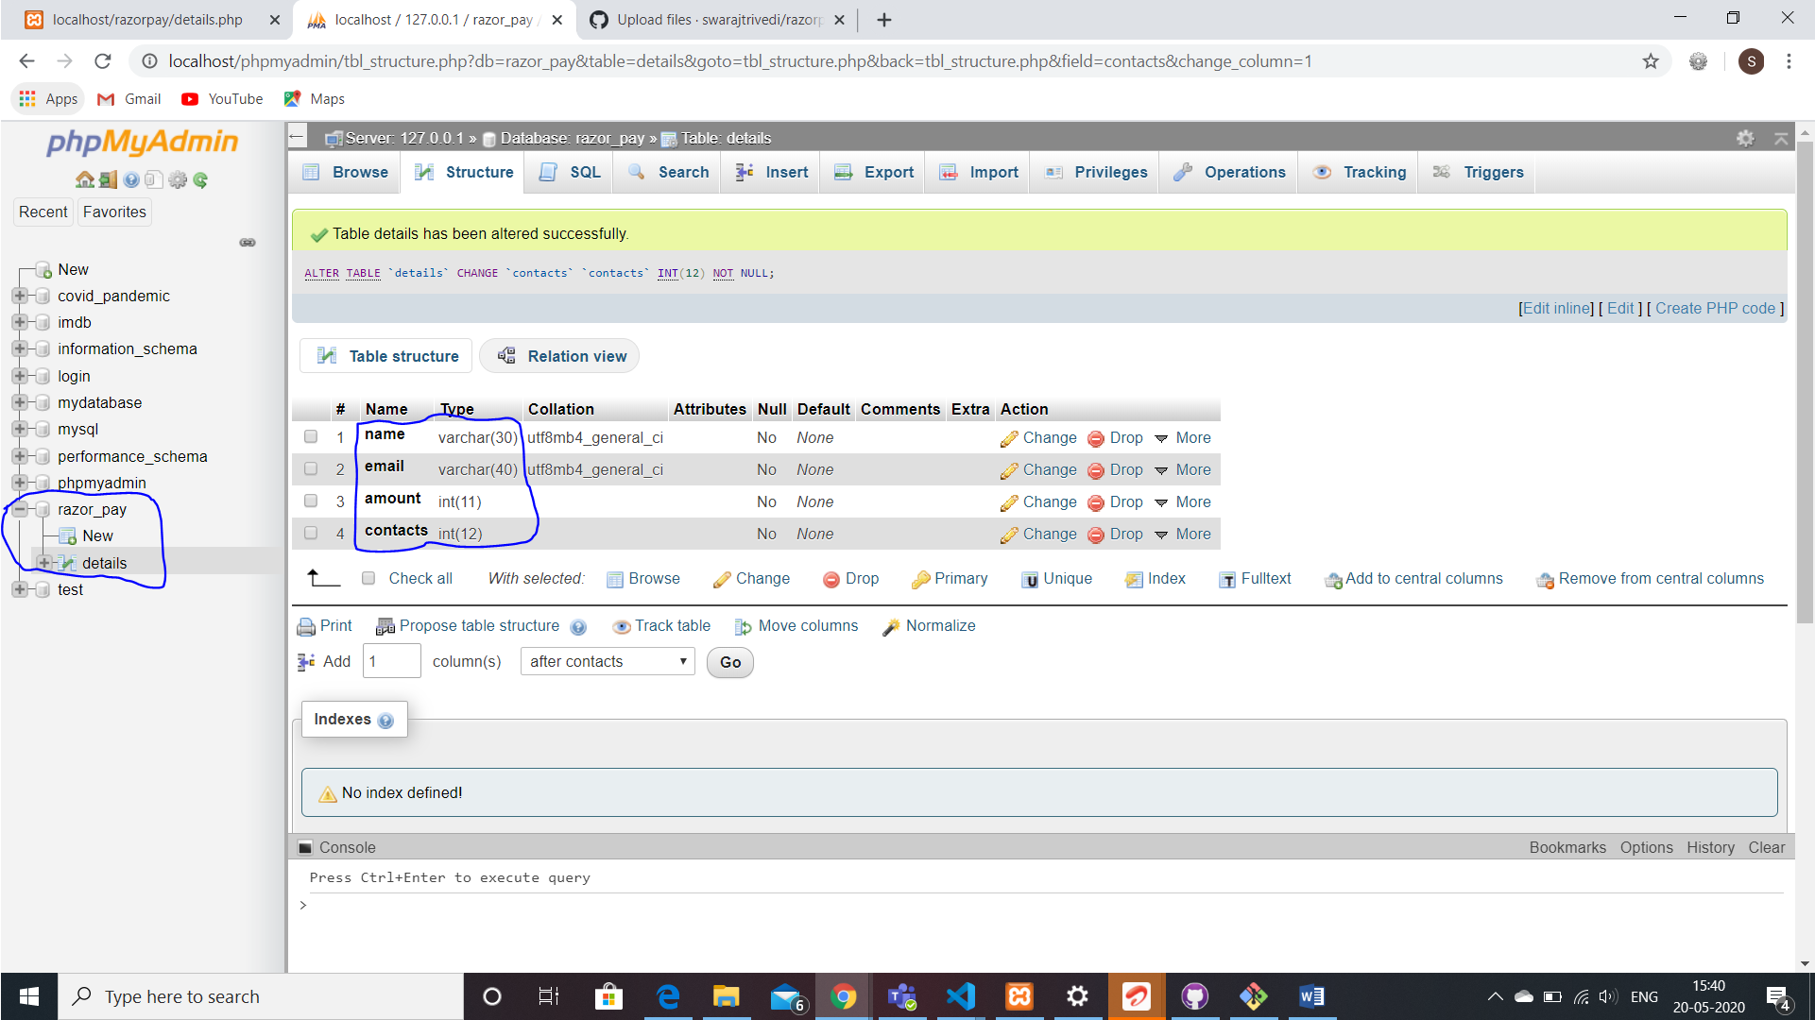

**Step 3 :**

Once the database and table are created , we can run the code .

Now go to the htdocs folder where you have copied the uploaded files.

Here you will find a file named “details.php”,which is our first file to be run,Open your browser and in the url type : “localhost/details.php”.

And you will see a form ,just fill it in.

The “amount” to be entered should be in paise.

**Screenshot:**

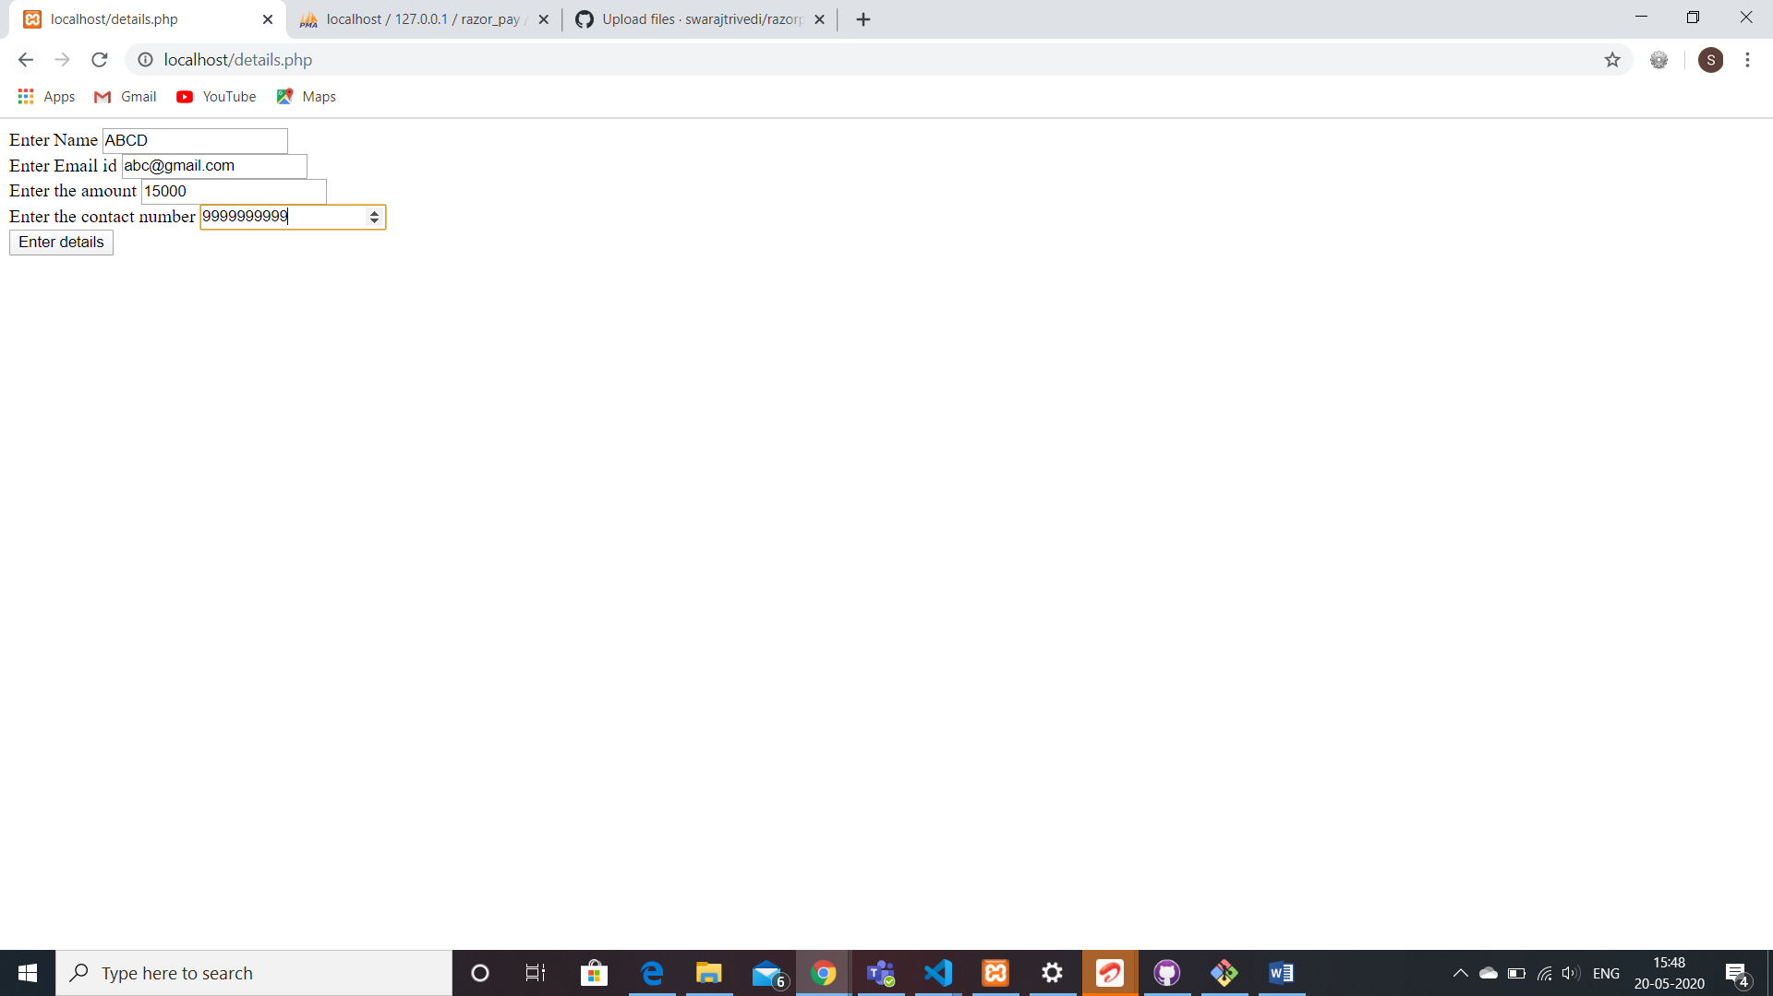

Once the form is filled correctly , it will redirect you to the detail.php page where you need to click the “redirect to payments “ link in order to make payment.

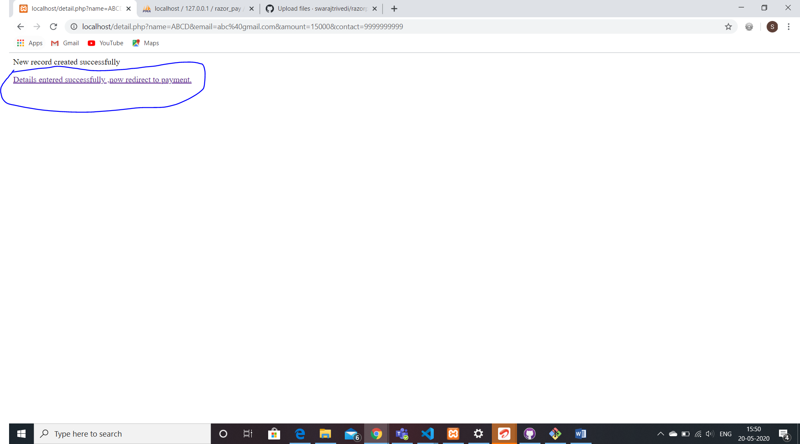

**Step 4:**

**Click Pay with Razorpay button. It will direct you to the secure gateway:**

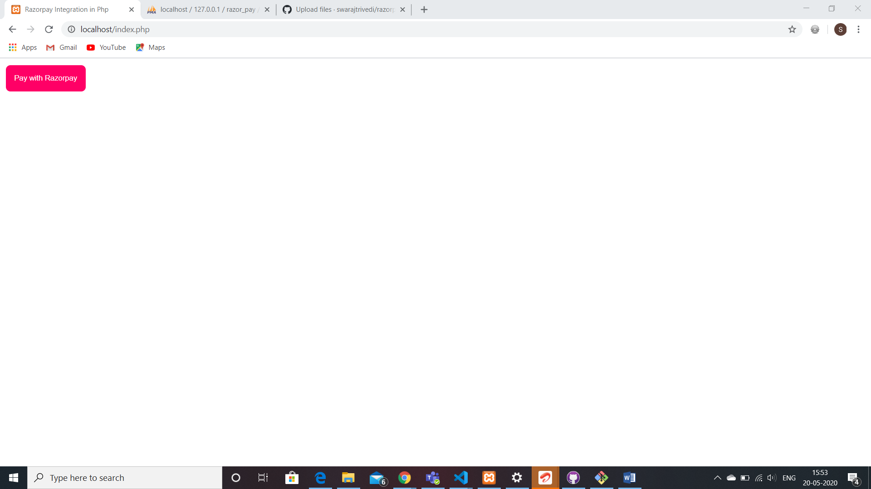

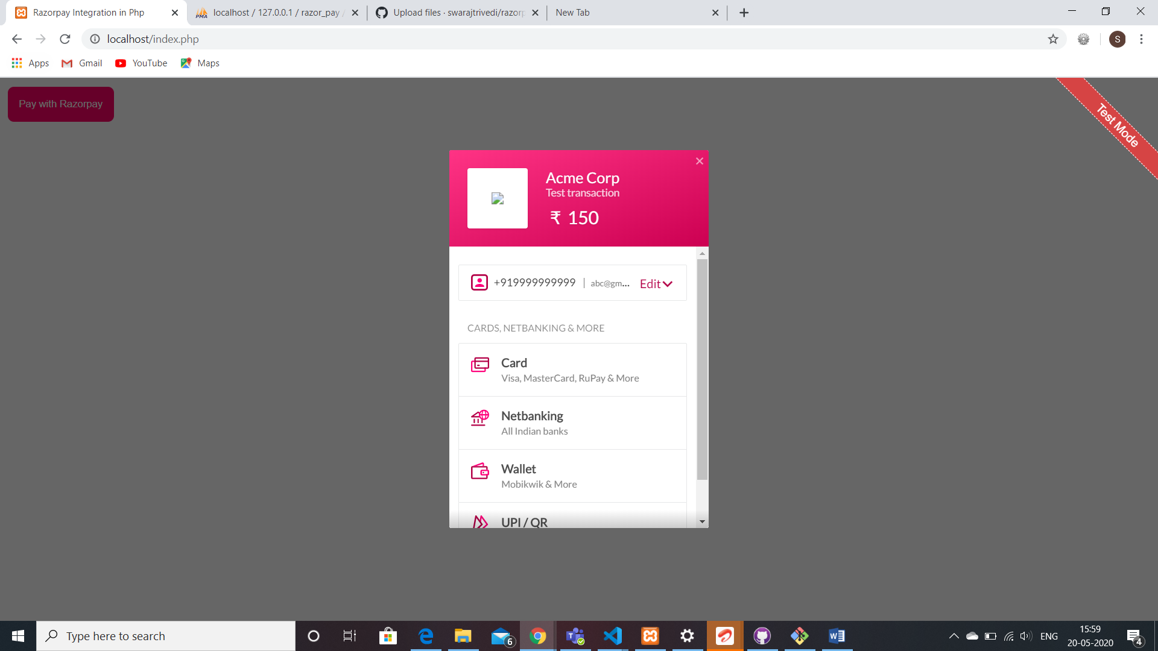

**You can see the details you entered and verify.**

**Step 5:**

**Making payments :**

Once all the details have been entered you can start paying by any mode.

For paying by card:

The test card number is “4111-1111-1111-1111”.And you may enter any random CVV to pay .

After paying you will be redirected to success.html page showing the transaction is complete.(Also you can skip saving any card if you want to).

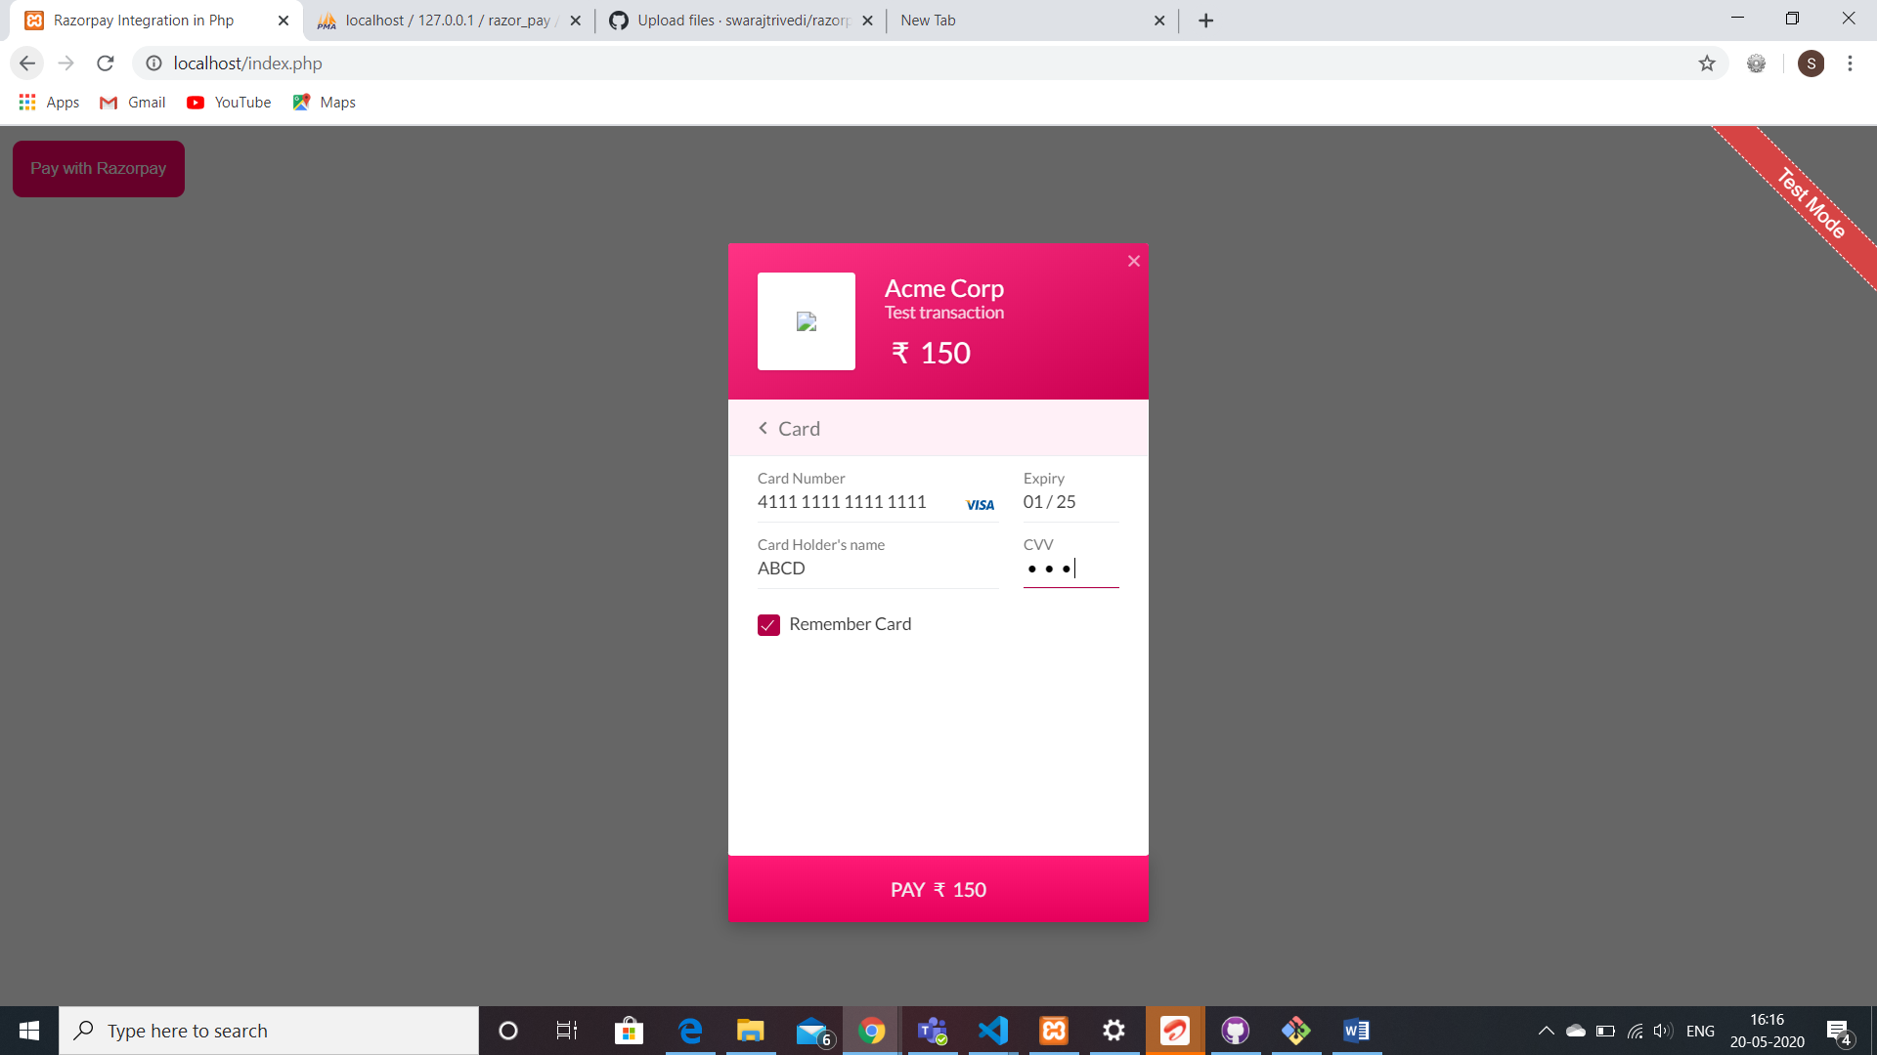

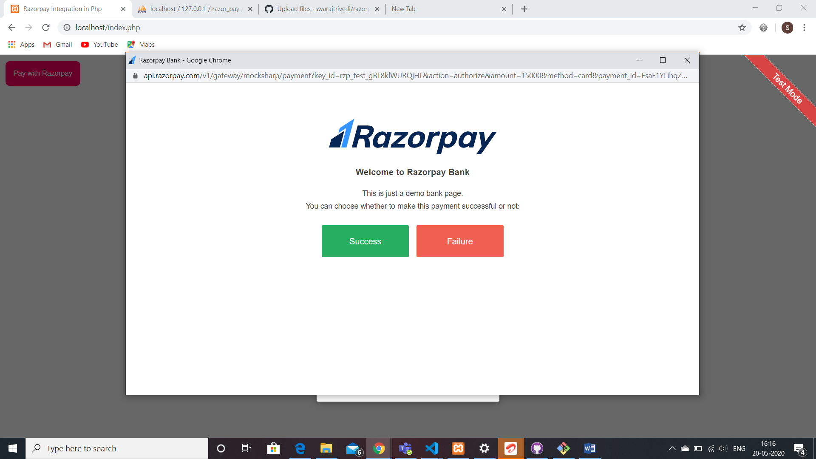

Click on success:

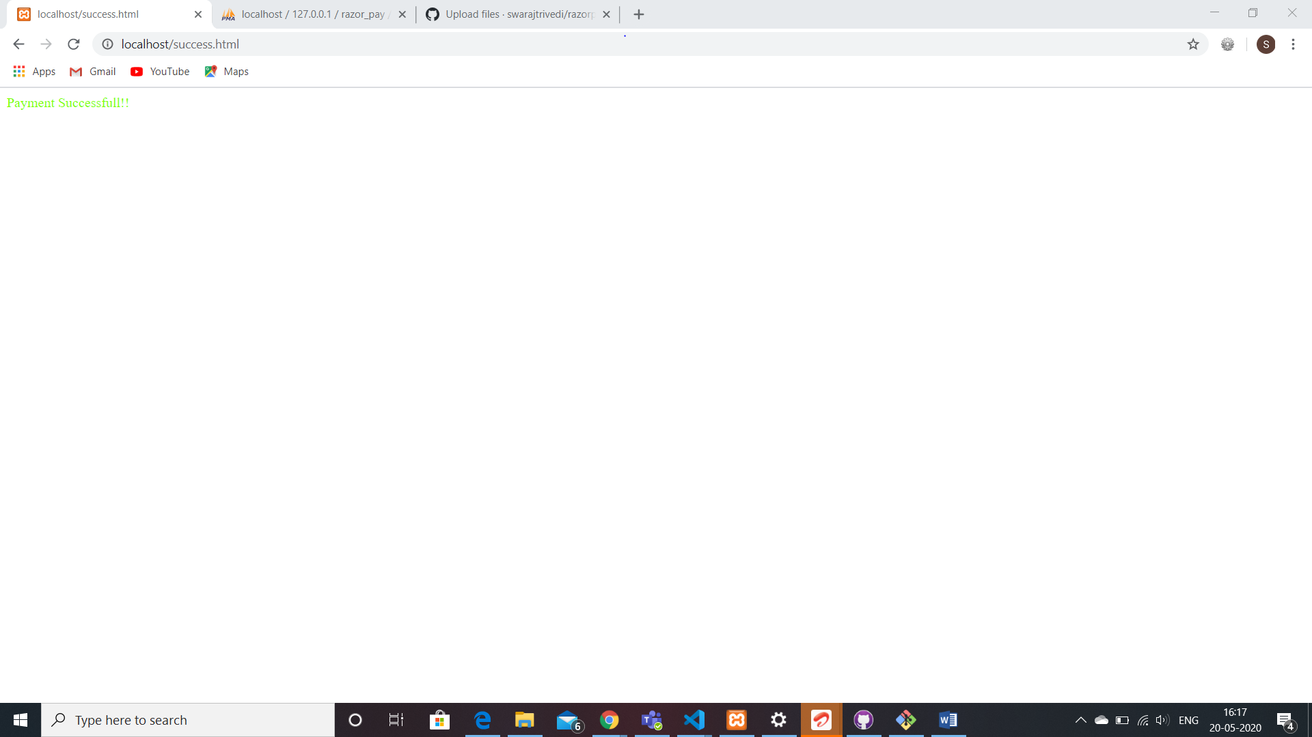

Step 6:

You can check the transactions made in your razorpay account,in the transactions column.

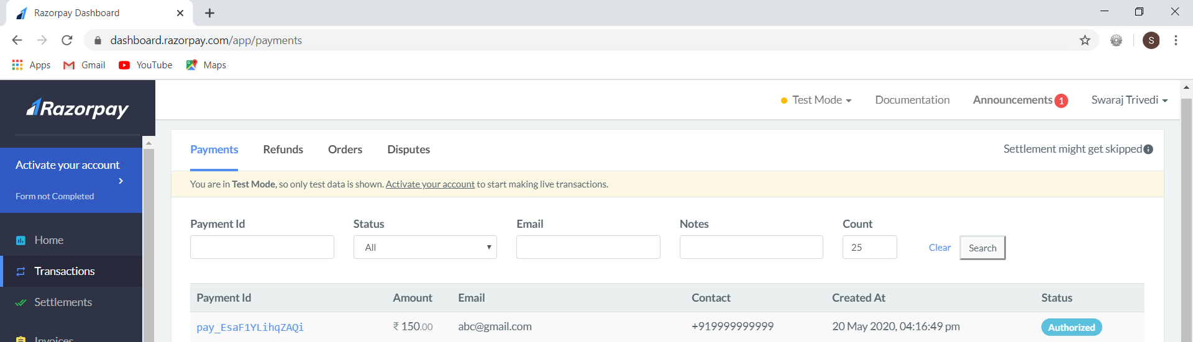

Step 7:

**HAPPY TRANSACTIONS!!**